Customer journey map
Date | 14 APRIL 2025
Team ID | SWTID1742640402
Project Name | MyRide
Maximum Marks | 4 Marks

Passenger Journey
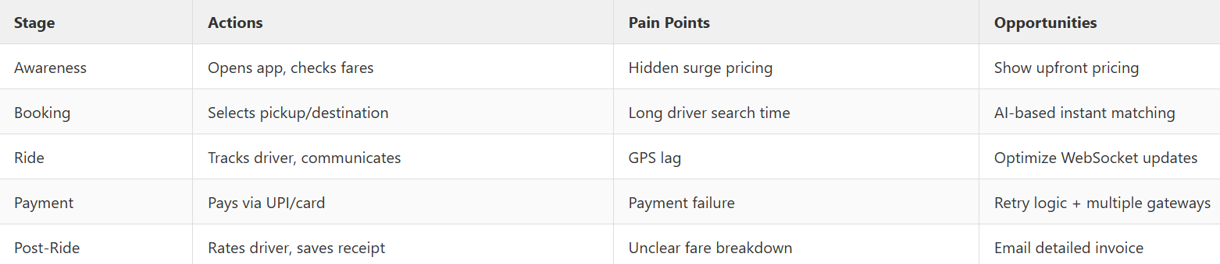
Driver Journey
